Kathy Rothschild
and
Ross Tatum
invite you to share in their joy
as they exchange their marriage vows
on Saturday, December 27th, 2003
at 5:00 PM

Ceremony followed by
buffet dinner, music and celebration

38 Hamilton Terrace
Harlem, New York

Please R.S.V.P.

wedding@kathyrothschild.com
or 212-222-7745

(See reverse side for directions.)

DIRECTIONS TO WEDDING AT 38 HAMILTON TERRACE

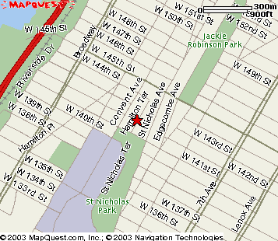

By Car: Take Broadway to West 142nd Street and turn east. Turn right on Convent Avenue. Turn Left on West 141st Street. Turn left on Hamilton Terrace and go to the brownstone at: 38 Hamilton Terrace.

By Train: Take the A or C line to 145th Street station. Walk one block west to Convent Avenue, then turn left onto West 144th Street. Walk a half block on West 144th Street to Hamilton Terrace, turn right and go to the brownstone at:
38 Hamilton Terrace.

Your presence is the most precious gift to us

Wish List
For those of you who do wish to give a gift, our good friend and neighbor Jana Kolpen designed a beautiful set of dinnerware called Pistoulet which has become our kitchen theme.

Registry Information for Pfaltzgraff PISTOULET Pattern

By Phone: Call 800-777-1877 and use the listing Ross Tatum, New York, NY.

Online: http:// www.pfz.com click on Gift Registry and then click on “See a Friend’s Wish List” and enter the following email address: wedding@kathyrothschild.com

Or you can make it easy on yourself and call the 800 number. We would be delighted with a gift certificate towards the dinnerware.

